Başkent Üniversitesi
Elektrik - Elektronik Mühendisliği
Bölümü

EEM 312 – Sayısal Elektronik

Ön Çalışma

Deney Adı | : NMOS ve PMOS elemanlarının karakteristiklerinin incelenmesi
Deney Numarası | : 7 / Y4
Adı Soyadı | : Buğra Bayram
Numara | : 20193272
Deney Tarihi | : 18 / 4 / 2007

1.Grup 2.Grup
Laboratuvar Grup Numarası :

A406 A407 B407 B408 C403 C407
Laboratuvar Dersliği :

Saturation current:
Often the electrical current in a system increases with the voltage applied, but only up to a certain point. The value which limits the current is the saturation current. The physical cause may be a fixed density of charge carriers and a maximum possible value for their velocity.In transistors, velocity saturation usually occurs before the transistor goes into saturation.The drain current, I_{D}, is constant so that integration results in:
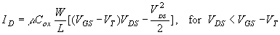
The drain current first increases linearly with the applied drain-to-source voltage, but then reaches a maximum value. According to the above equation the current would even decrease and eventually become negative. The charge density at the drain end of the channel is zero at that maximum and changes sign as the drain current decreases. The charge in the inversion layer does go to zero and reverses its sign as holes are accumulated at the interface. However, these holes cannot contribute to the drain current since the reversed-biased p-n diode between the drain and the substrate blocks any flow of holes into the drain. Instead the current reaches its maximum value and maintains that value for higher drain-to-source voltages. A depletion layer located at the drain end of the gate accommodates the additional drain-to-source voltage. This behavior is referred to as drain current saturation.
Drain current saturation therefore occurs when the drain-to-source voltage equals the gate-to-source voltage minus the threshold voltage. The value of the saturated drain current, I_{D,sat}. is then given by the following equation:
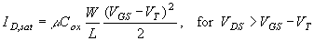
The quadratic model explains the typical current-voltage characteristics of a MOSFET, which are normally plotted for different gate-to-source voltages. The saturation occurs to the right of the dotted line which is given by I_{D} = μ C_{ox} W/L V_{DS}².
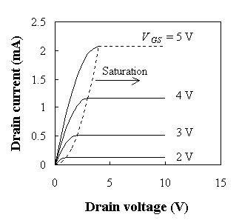
The drain current is still zero if the gate voltage is less than the threshold voltage.
For negative drain-source voltages, the transistor is in the quadratic region.
However, it is possible to forward bias the drain-bulk p-n junction. A complete circuit model should therefore also include the p-n diodes between the source, the drain and the substrate

Channel-Length Modulation:
Channel length modulation in a MOSFET is caused by the increase of the depletion layer width at the drain as the drain voltage is increased. This leads to a shorter channel length and an increased drain current. The channel-length-modulation effect typically increases in small devices with low-doped substrates. An extreme case of channel length modulation is punch through where the channel length reduces to zero. Proper scaling can reduce channel length modulation, namely by increasing the doping density as the gate length is reduces.
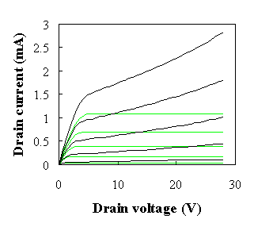

Velocity Saturation:
The linear relationship between the average carrier velocity and the applied field breaks down when high fields are applied. As the electric field is increased, the average carrier velocity and the average carrier energy increases as well. When the carrier energy increases beyond the optical phonon energy, the probability of emitting an optical phonon increases abruptly. This mechanism causes the carrier velocity to saturate with increasing electric field. For carriers in silicon and other materials, which do not contain accessible higher bands, the velocity versus field relation increases monotonically
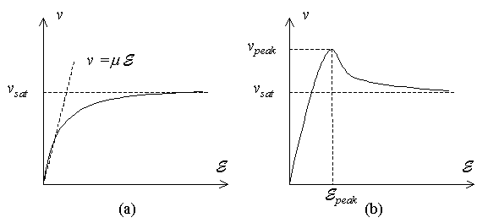
For those materials the velocity-field relation can be described by:
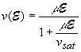
The maximum obtainable velocity, v_{sat}, is referred to as the saturation velocity.
The analysis is more complex for materials such as GaAs and InP, which contain multiple closely spaced conduction band minima. Electrons originating in the lowest Γ minimum accelerate under high field conditions and gain enough energy to transfer to the X or L minima. Since the density of states in the X and L minima is much higher because of the higher effective mass, the probability that the electron transfers back into the Γ minimum is small because of the small number of available states. The electrons therefore remain in the higher minima as long as the electric field exceeds the peak field. The corresponding velocity initially increases with increasing applied electric field. However as carriers transfer to the higher minimum with a higher effective mass, the average carrier velocity decreases. This causes a distinct peak in the velocity field curve. Such velocity-field curves are therefore characterized by the peak velocity, v_{peak}/i>, and the peak field, E_{peak}, in addition to the mobility, μ, and the saturation velocity, v_{sat}.
While this equation can at best provide a rough estimate of the actual saturation velocity, it does indicate the right trend. Materials with a small effective mass and high optical phonon energy are more likely to have a high saturation velocity. Materials with multiple band minima can have a rather low saturation velocity.
Hot-Carrier Effect:
As the gate-oxide is scaled down, breakdown of the oxide and oxide reliability becomes more of a concern. Higher fields in the oxide increase the tunneling of carriers from the channel into the oxide. These carriers slowly degrade the quality of the oxide and lead over time to failure of the oxide. This effect is referred to as time dependent destructive breakdown (TDDB).
Oxides other than silicon dioxide have been considered as alternate oxides and are typically referred to as high-k dielectrics. These oxides have a larger dielectric constant so that the same gate capacitance can be obtained with a thicker oxide. The challenge is to obtain the same stability, reliability and breakdown voltage as silicon dioxide. Oxides of interest include Al2O3, ZrO and TiO
Metal Migration:
When the current is too high, electron flow pushes around metal grains. Higher resistance increases metal migration, leading to destruction of wire.
Marginal wires will fail,after a small operationg period called infant mortality. Normal wires must be sized to accomodate maximum current flow:
Imax: 1.5mA/um of metal width
Mainly applies to Vdd/Vss lines.
CMOS-Latch-Up:
There are two ways to initiate latch-up in CMOS structures. One is to apply a positive voltage greater than 5V to the Vdd contact. The other condition is to apply a negative voltage to the Vss contact. It is possible to simulate latch-up in DC mode by applying a biasing ramp to the Vss contact.
